 | Press Release | 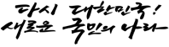
Press Release Date and Time | Wednesday, August 2, 2023 12:00 PM
Korea’s Immigration Service, the Best in the World!
Songpa-gu’s Diaper Changing Station
in a Men’s Restroom, the First in Korea!
- MOIS selected six innovation cases as the First and Best in Government Innovations that make people’s lives easier and are recognized globally.
- The Korean Intellectual Property Office introduced the World’s first online patent application system.
- Seoul Metropolitan City and Jeonju City are the best in Korea for installing and maintaining sidewalks, and the Pay-as-you-throw garbage bag of the Seongnam City of Gyeonggi-do stands out as the best in the country.

The Ministry of the Interior and Safety (MOIS, Minister LEE Sang-min) has selected and announced the six exemplary cases of the 2nd “First and Best in Government Innovation” in collaboration with the Korea Institute of Public Administration.

Category | Best Practice
Best in the World | Immigration service: Incheon Airport Immigration Office, Ministry of Justice
First in the World | Online patent application: Korean Intellectual Property Office
First in Korea | Installation of a diaper changing station in a men’s public restroom: Songpa-gu, Seoul
Best in Korea | Sidewalk installation and maintenance (2): Seoul Metropolitan City and Jeonju City, Jeollabuk-do  Pay-as-you-throw garbage bag: Seongnam City, Gyeonggi-do
The immigration service of the Incheon Airport Immigration Office under the Ministry of Justice has been selected as the world’s best practice of government innovation. In March of this year, it was named the winner of the Best Immigration Service at the “World Airport Awards 2023*”, raising the pride of Koreans for its outstanding public services unmatched by any other country.
* The survey was conducted by Skytrax, an international air transport rating organization, among passengers at 427 airports worldwide.
The immigration service of the Incheon Airport has enabled swift immigration screening and secure border management through continuous innovation, such as adopting cutting-edge technology and system improvement*.
* Introduction of the Smart Entry Service (an automatic immigration clearance system), i-PreChecking system (a passenger pre-verification system), and flexible arrangement of screening officers based on passenger flow, etc.

The Korean Intellectual Property Office (KIPO) launched the world’s first online patent application system in 1999* through government innovation, highlighting the excellence of Korea’s public administration.
* Launch year of the online patent application of each country: US and EU in 2000, WIPO (UN) in 2005, Japan in 2005

Three million online patent applications were filed for the first ten years, and approximately 8.75 million were filed over the 24 years until the end of last year. The online application system has also been exported to the United Arab Emirates (UAE) and Azerbaijan.

In the meantime, Songpa-gu in Seoul is the first place to install a diaper changing station in a men’s public restroom, which is easy to see now. In March 2007, Songpa-gu installed a diaper changing station in the men’s restroom of the district office and the Sports and Culture Center for the first time in Korea for fathers who go out with their babies. This initiative created an environment where men could easily care for babies and improved the system.

This case became the cornerstone for the MOIS to revise the Public Toilets Act (February 4, 2010), which mandates the installation of a diaper changing station in men’s public restrooms of a certain size.

Three local governments have been selected as Korea’s best institutions for sidewalk installation and maintenance and Pay-as-you-throw garbage bag.

In sidewalk installation and maintenance, Seoul City was selected as the metropolitan local government for its systematic and efficient installation and maintenance of sidewalks by introducing permeable blocks and a real-name system for sidewalk construction. Among local governments, Jeonju City in Jeollabuk-do was selected for its design of sidewalk blocks that reflect local characteristics and the installation of sidewalks prioritizing pedestrian convenience and durability.

In the field of Pay-as-you-throw garbage bags, Seongnam City in Gyeonggi-do was selected for providing bags of various sizes to reflect residents’ demand, inducing proper garbage discharge with simple and user-friendly designs (pictograms and QR codes), and enhancing citizen convenience.

MOIS will grant certification plaques to the selected institutions to boost their pride and facilitate active benchmarking among institutions. More details on the selected best and first practices can be found on the government innovation website "Innovation 24” (innovation.go.kr).

Institutions aiming to receive the First and Best in Government Innovation certifications can submit their applications to MOIS anytime. And the best practices will be selected from different categories each time.

JEONG Seon Yong, Deputy Minister for Government Innovation and Organization Management, said, “Selecting the First and Best in Government Innovation aims to spread the achievements of the Korean government’s innovation at home and abroad.” “We will widely promote the selected best practices so that innovation can be sparked in more places,” he further mentioned.

Division in Charge | Government Innovation and Organization Management Office  Innovation Planning Division | Manager | Director | KO Eunyoung | 044-205-2201
Division in Charge |  | Staff in Charge | Deputy Director | KIM Yongkwan | 044-205-2210

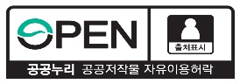

Reference |  | Photos of the 2nd “First and Best in Government Innovation”

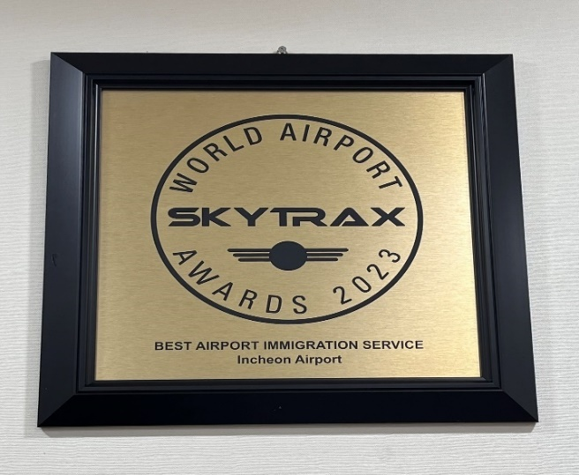 |  | 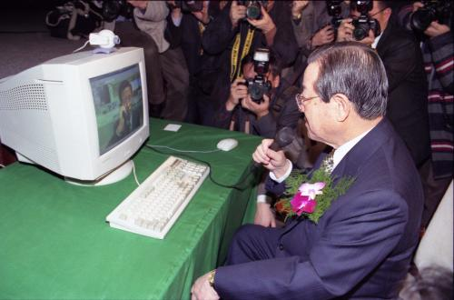
World’s Best Airport Immigration Service  (Incheon Airport Immigration Service,  Ministry of Justice) |  | World’s First Online Patent Application  (Korean Intellectual Property Office)  (PatentNet Opening Ceremony attended by the former Prime Minister KIM Jong Pil)
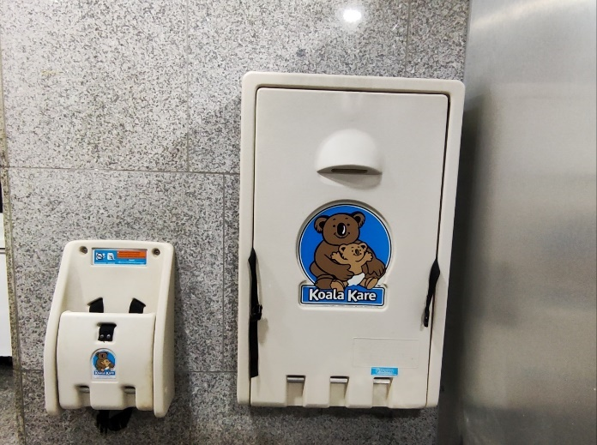 |  | 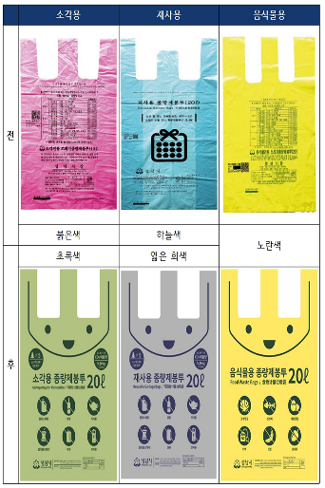 | 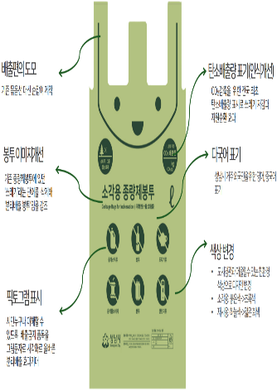
Korea’s First Diaper Changing Station in a Men’s Public Restroom (Songpa-gu, Seoul) |  | Korea’s Best Pay-As-You-Throw Garbage Bags (Seongnam City, Gyeonggi-do)
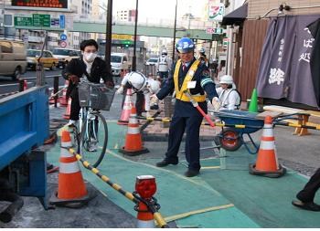  Pedestrian Safety Assist | 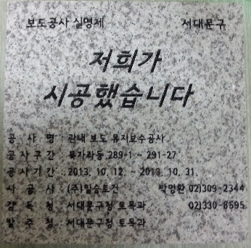  Real-Name Signage for Sidewalk Construction | 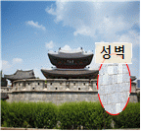 | 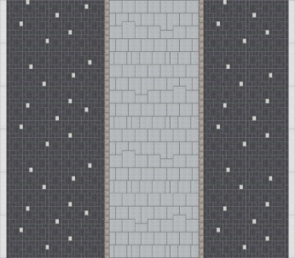
 |  | 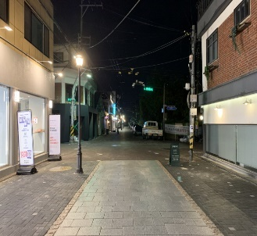 | 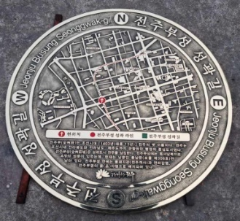
Korea’s Best Sidewalk Installation and Maintenance  (Metropolitan: Seoul Metropolitan City) |  | Korea’s Best Sidewalk Installation and Maintenance  (Local government: Jeonju City, Jeollabuk-do)

